ANR Scoring & Visualisation software

# Overview

The ANR scoring & Visualisation software is used for the creation and technical management of ANR flight competitions, including

* creation of a competition
* management of participants and crews
* management of competition tasks (qualification rounds)
* import of maps and map overlays (called “parcour”) used in competition tasks
* print-out of the competition map with overlay
* calculation of penalty points from flight data

The following functionality/features are OUTSIDE of the scope of the ANR scoring & Visualisation software:

* management of the ANR landing competition part
* real-time tracking

# Program version

This document describes the functionality of the ANR Scoring & Visualisation software, version 1.0.13. (as per autumn 2016).

# History

* Original development started in 2008-2009 (Commercial and Industrial Training college Bern, GIBBS)
* Platform: Windows (programmed in C# on Microsoft .NET 4.5 framework)
* Functionality:
  + Set-up of an ANR competition
  + Planning and print-out of competition routes (“parcours”)
  + Calculation of penalty points based on logger data
  + Originally developed as a client-server application, with integration of real-time tracking with mobile phone technology (tracking data saved centrally).
  + Due to technical limitations the real-time integration was never fully operational and has been discontinued.
* In 2015 the centralized server-based version was discontinued in favor of a stand-alone version
* In 2016, major face-lifting of the user interface, bug corrections, streamlining and implementation of new features during 2016.

# What is new?

* The user interface has been reviewed and streamlined
* Visualisation has been discontinued (the former plug-in is not operational anymore since Dec 2015)
* Route generator for parcour overlay creation in Google Earth
* Take-off lines (used for qualification round) can also be imported from the same file
* Internationalization issues (comma/dot as a decimal separator) fixed

# A brief overview

**Competition, Participants, crews**

A ***competition*** is the main entity. ***Participants*** and ***Crews*** are registered on a per-competition base. Crews are composed from these available participants (and therefore also crews are registered per competition).

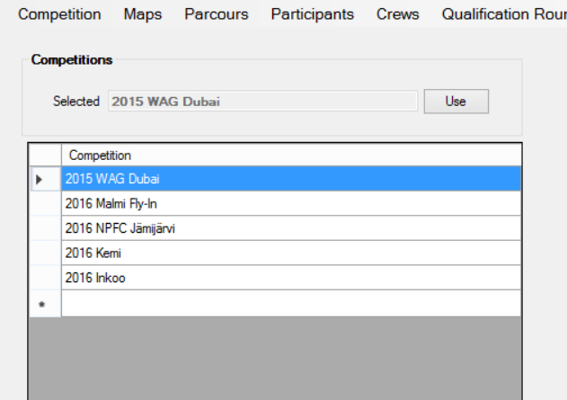 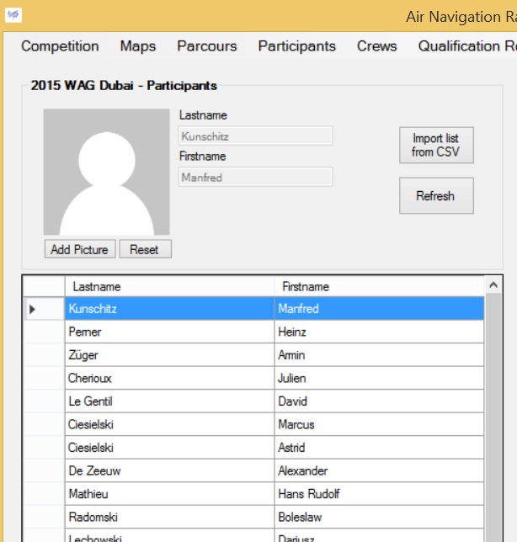

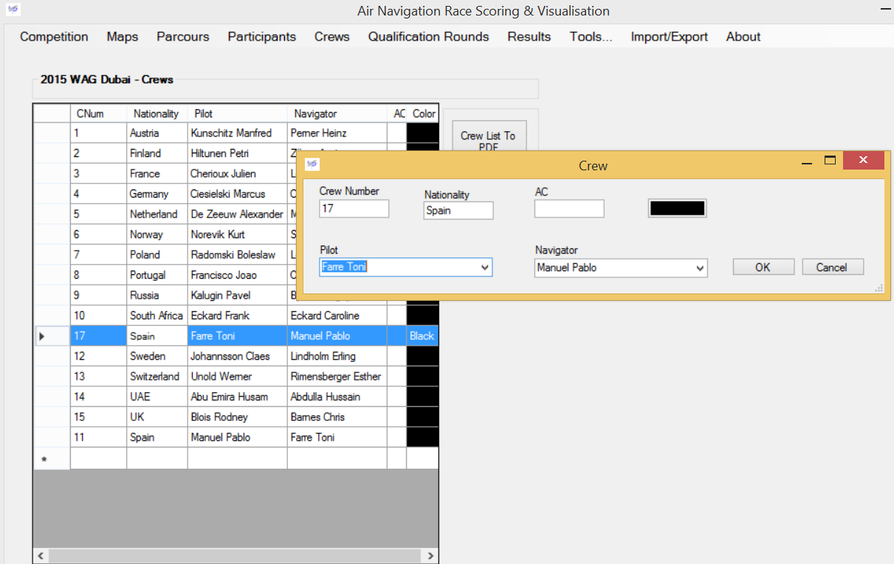

**Competition, maps, parcour, qualification round**

Each competition consists of one or several competition tasks (called ***qualification rounds***).

A qualification round needs a defined race area (called ***parcour***). This parcour is built on a background ***map*** and an overlay which defines the channels in which the competitors are supposed to fly. This overlay also includes take-off lines, starting point line and final point lines. It also may include a so-called non-return line. Note that a parcour may have 1-4 “channels” (limited by the software), allowing 1-4 flights.

Both maps and the parcour (built on a selected map) are stored on a per-competition base. It is not uncommon to combine a single map with several parcour overlays, therefore allowing the creation of several parcours.

**Map import**

Map import is one crucial point that every user must understand.

* You cannot just import a map picture, you must let the application know the coordinates.
* There are hundreds of different coordinate reference systems, however they are standardized.
* The ANR scoring & visualization software requires a map to be in the WGS84 coordinate reference system (CRS). The technical name of the CRS is **EPSG: 4326** )
* The map you want to use is probably not in the correct CRS (check your map for details!), so it must be converted (re-projected) into the WGS84 CRS.
* The converted map picture will come with a small text file (a so-called World file) which contains the required coordinate information.

You can use your own scanned maps, or map data available in electronical format. Note that the ANR scoring & visualization software requires image files (vector graphics etc. are not yet supported).

The process of re-projecting is not really difficult. There is free software available for this purpose, or you can purchase the re-projection from a specialist.

***Please see also the separate documentation “ANR Map conversion”. There are also 2 videos on YouTube available:***

[***https://www.youtube.com/watch?v=997MSiTg1Ww***](https://www.youtube.com/watch?v=997MSiTg1Ww) (map and map import)

[***https://www.youtube.com/watch?v=VDiG4fO4D1c***](https://www.youtube.com/watch?v=VDiG4fO4D1c) (scanning your own maps)

**Parcour creation**

The parcour creation used to be the second stumbling stone in the past. In former versions, the overlay had to be created in an AutoCAD format (*.dxf) and thus required a software with AutoCAD capabilities, which made it difficult to use.

One of the major changes in the software is the way how the parcour overlay can be created. The updated version allows to create the overlay in Google Earth, and import it into the ANR scoring & visualization software. This option is available under “Tools-Route Generator”.

***Please see also the separate documentation “ANR Route Generation”. There is also a video available on YouTube:***

[***https://www.youtube.com/watch?v=PrMDthexN5M***](https://www.youtube.com/watch?v=PrMDthexN5M)(Route generation)

**Qualification round and starting list**

Back to the qualification round. Once we select the parcour for a qualification round, we can then build a starting list based on the available crews. This starting list is the base for the actual flight task of the participants.

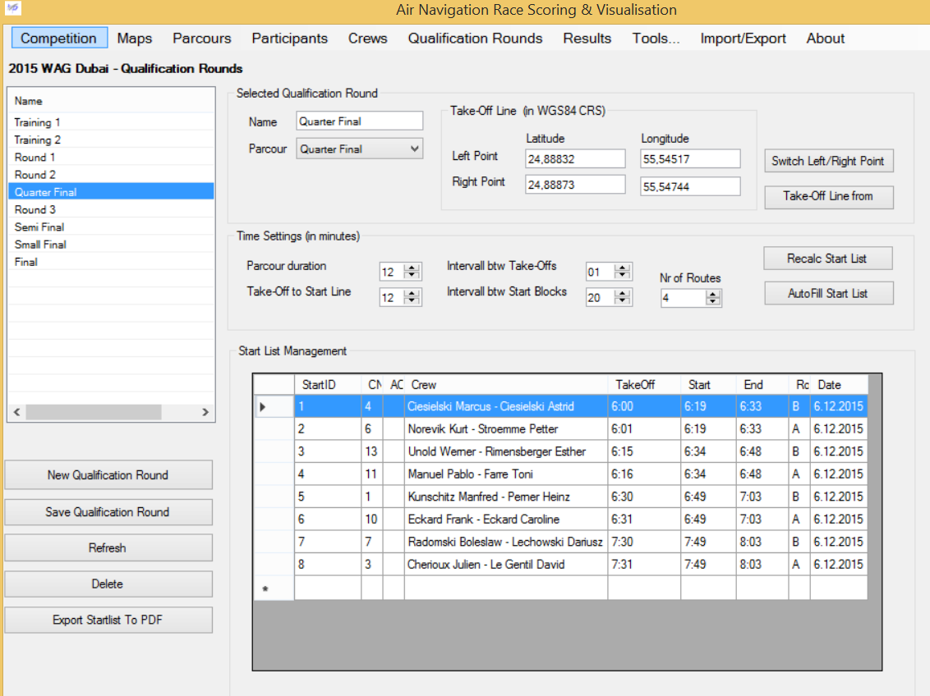

**Results**

After the flight the available logger data is imported into the ANR Scoring & visualization software (under “Results”). The import format is either the dedicated *.gac format or the even more common *.gpx format.

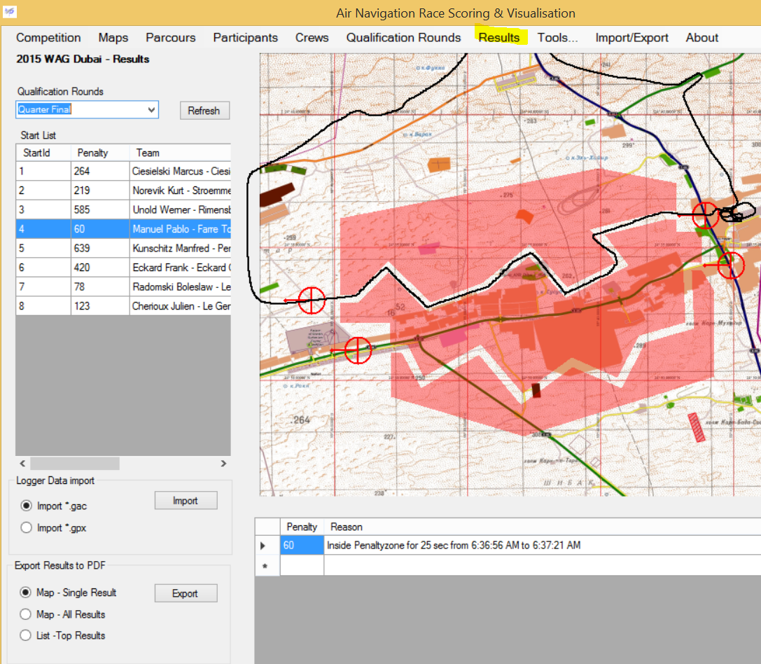

**Import/Export**

Data can also be exported: the parkour can be exported as *.kml format file (this may be required if the original input data was not *.kml). Also qualification roud data may be exported to Excel for simplified handling.

Flights may be exported as *.gpx (in case they have been imported in *.gac format). Note that the *.gpx format can be opened from Google Earth.

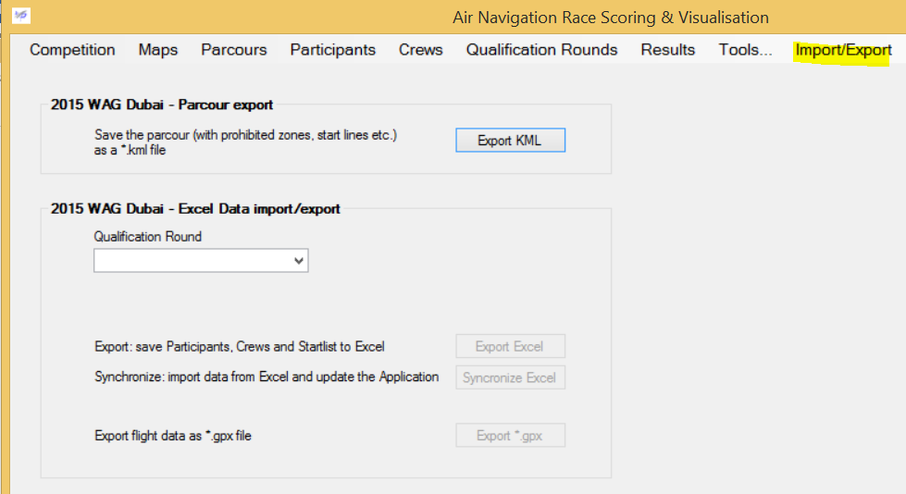

**Tools**

The ***Route Generator*** is used to create a parcour overlay that can be edited and adjusted in Google Earth, and then imported into the ANR Scoring and visualisation software.

The ***Legacy coordinate converter*** allows for coordinate conversion between the WGS84 Coordinate Reference System (CRS) and the Swiss CH1903 CRS.